**Prepare for the**

Proficient?

Advanced?

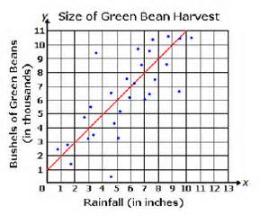

***Help!***

3*x* + 2*y* = 12

**Algebra 1 Keystone**

*f*(*x*) = 3*x*2 + 4*x*

**in the**

**Peer Math Tutoring Program**

**When: Every Wednesday from 2:50 p.m. to 4:20 p.m.**

**beginning September 30th**

**Where: Room A8**

Tutoring will be provided by *students* under the supervision of two math teachers. As you work with a student who has successfully passed the Algebra 1 Keystone, you can build/strengthen the skills needed to pass this assessment. You and your tutor will be able to focus on specific areas of weakness. Practice materials similar

to the Algebra 1 Keystone (sample tests from the Pennsylvania Department of Education, worksheets, workbooks) will be provided.